**PROJECT TITLE: DATA ANALYST PORTFOLIO PROJECT – CREATE A QUERY, ANALYSE AND DASHBOARD CREATION FOR THE .CSV FILE OF PIZZA SALES USING SQL AND POWER BI**

**Scope:**

* Analyze pizza sales data to gain insights into customer behavior, popular products, and sales trends.
* Utilize SQL queries to extract, clean, and manipulate data from the .CSV file.
* Create visualizations using Power BI to present key findings in an accessible format.
* Identify patterns, correlations, and opportunities for optimization within the pizza sales dataset.

**SOFTWARE USED:**

MS OFFICE/EXCEL: VERSION 2023

MS SQL SERVER: 2022

SQL SERVER MANAGEMENT STUDIO - SSMS 19.3

POWER BI: 4 Mar 2024 Version: 2.126.1261.0

**KPI'S REQUIREMENT**

We need to analyze key indicators for our pizza sales data to gain insights into our business performance. Specifically, we want to calculate the following metrics:

1. Total Revenue: The sum of the total price of all pizza orders.

2. Average Order Value : The average amount spent per order, calculated by dividing the total revenue by the total number of orders.

3. Total Pizzas Sold: The sum of the quantities of all pizzas sold.

4. Total Orders: The total number of orders placed.

5. Average Pizzas Per Order : The average number of pizzas sold per order, calculated by dividing the total number of pizzas sold by the total number of orders.

**CHARTS REQUIREMENT:**

We would like to visualize various aspects of our pizza sales data to gain insights and understand key trends. We have identified the following requirements for creating charts:

1. Daily Trend for Total Orders:

Create a bar chart that displays the daily trend of total orders over a specific time period. This chart will help us identify any patterns or fluctuations in order volumes on a daily basis.

2. Monthly Trend for Total Orders:

Create a line chart that illustrates the hourly trend of total orders throughout the day. This chart will allow us to identify peak hours or periods of high order activity.

3. Percentage of Sales by Pizza Category:

Create a pie chart that shows the distribution of sales across different pizza categories. This chart will provide insights into the popularity of various pizza categories and their contribution to overall sales.

4. Percentage of Sales by Pizza Size:

Generate a pie chart that represents the percentage of sales attributed to different pizza sizes. This chart will help us understand customer preferences for pizza sizes and their impact on sales.

5. Total Pizzas Sold by Pizza Category:

Create a funnel chart that presents the total number of pizzas sold for each pizza category. This chart will allow us to compare the sales performance of different pizza categories.

6. Top 5 Best Sellers by Revenue, Total Quantity and Total Orders

Create a bar chart highlighting the top 5 best-selling pizzas based on the Revenue, Total Quantity, Total Orders. This chart will help us identify the most popular pizza options.

7. Bottom 5 Best Sellers by Revenue, Total Quantity and Total Orders

Create a bar chart showcasing the bottom 5 worst-selling pizzas based on the Revenue, Total Quantity, Total Orders. This chart will enable us to identify underperforming or less popular pizza options.

**SQL QUERYING**

**1. CONNECT OUR SQL SERVER WITH THE SYSTEM**

**2. CREATE A NEW DATABASE – PIZZA DB**

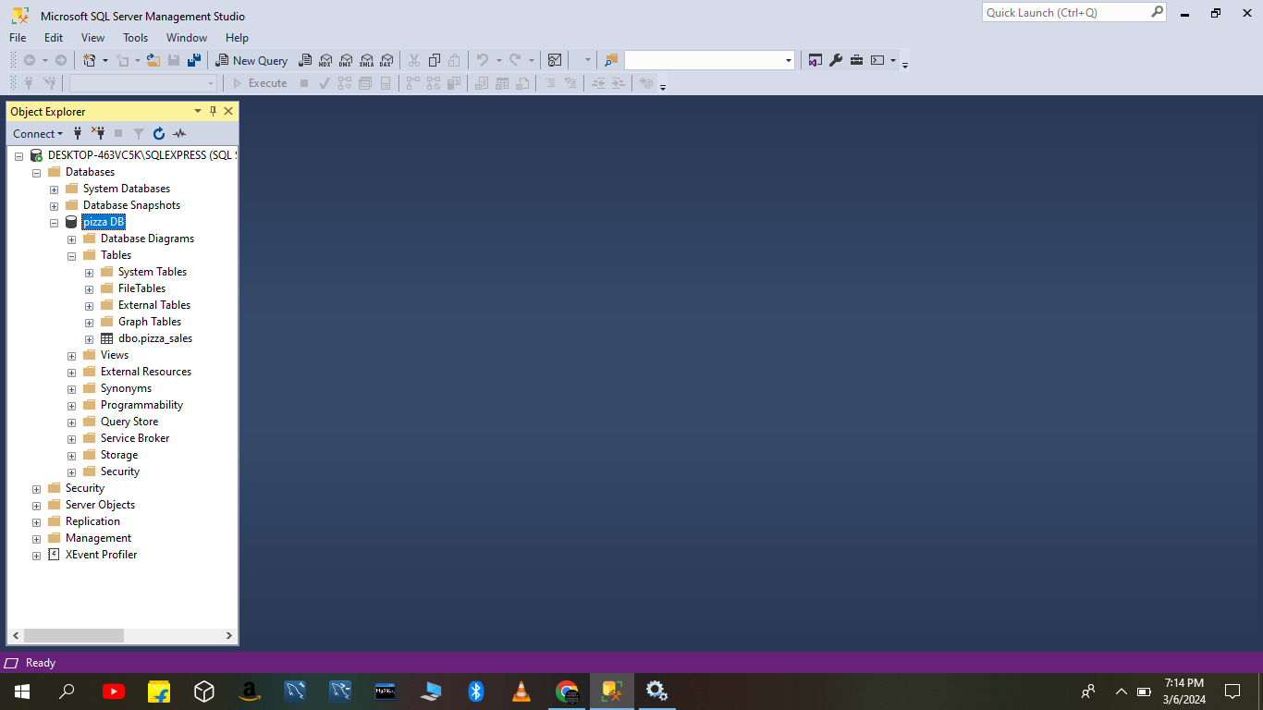

**3. IMPORT THE DATA , CLICK PIZZA DB=>TASKS=>IMPORT FLATFILE=> SELECT THE LOCATION &FILE =>GIVE NEW TABLE NAME=> CLICK NEXT =>MODIFY THE DATA TYPE INTO SUITABLE TYPE => FINISH.**

**4. CREATE A NEW QUERY**

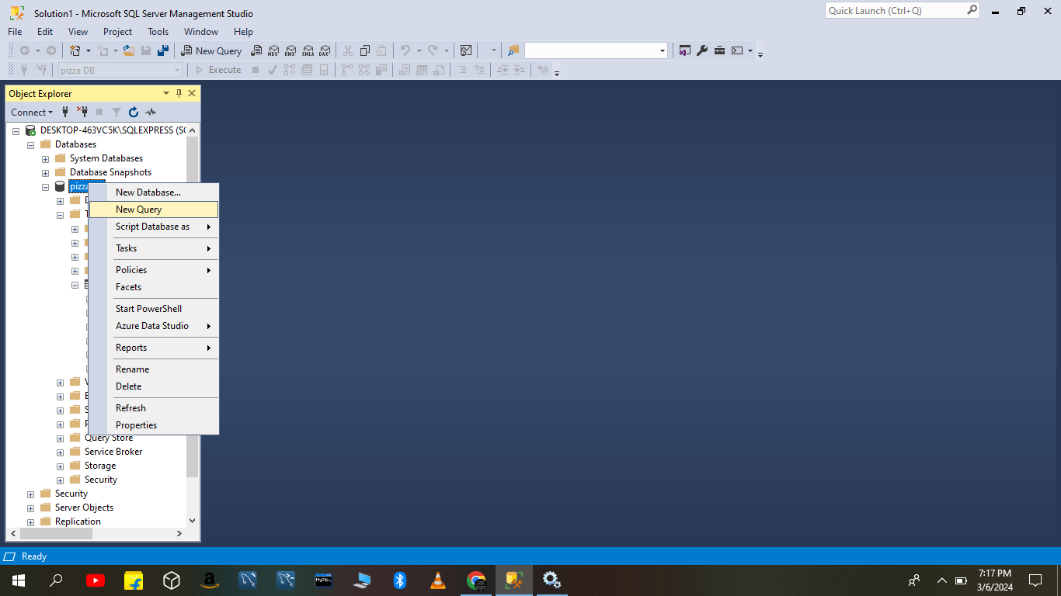

**5. CHECK THE TABLE IS CREATED CORRECT BY QUERYING**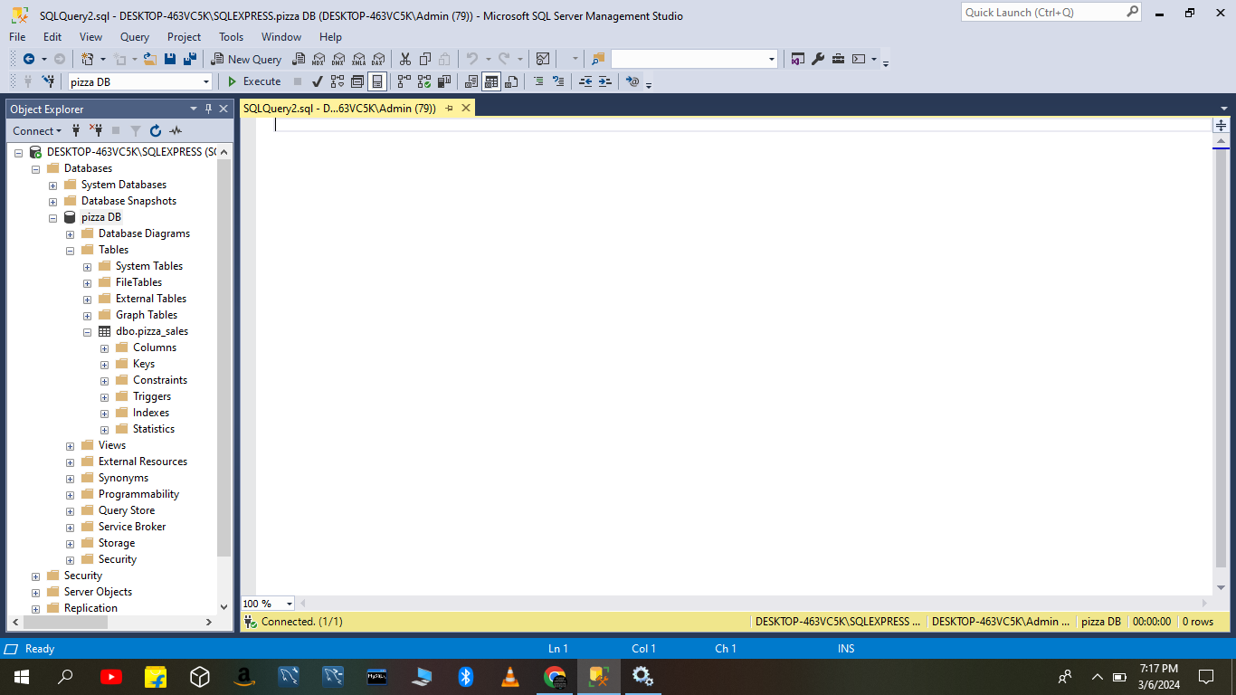

**6. TO DISPLAY THE TABLE**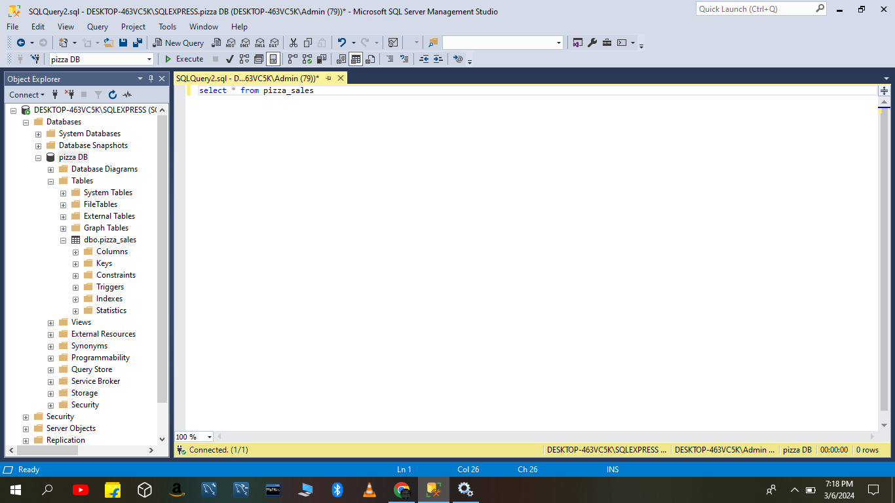

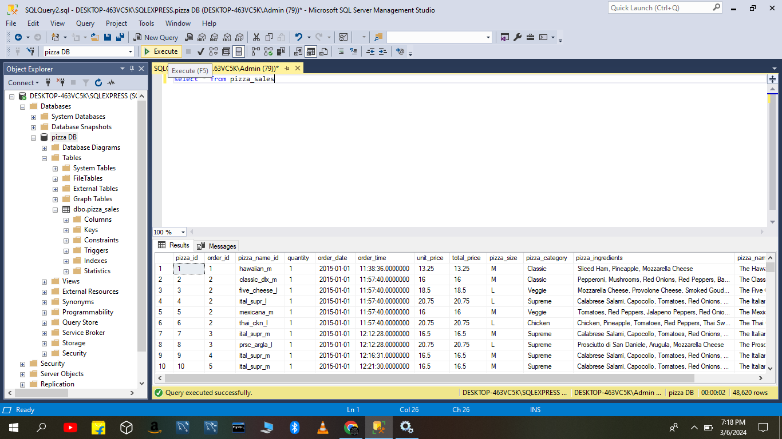

**7. TO FIND:**

**A. TOTAL REVENUE**

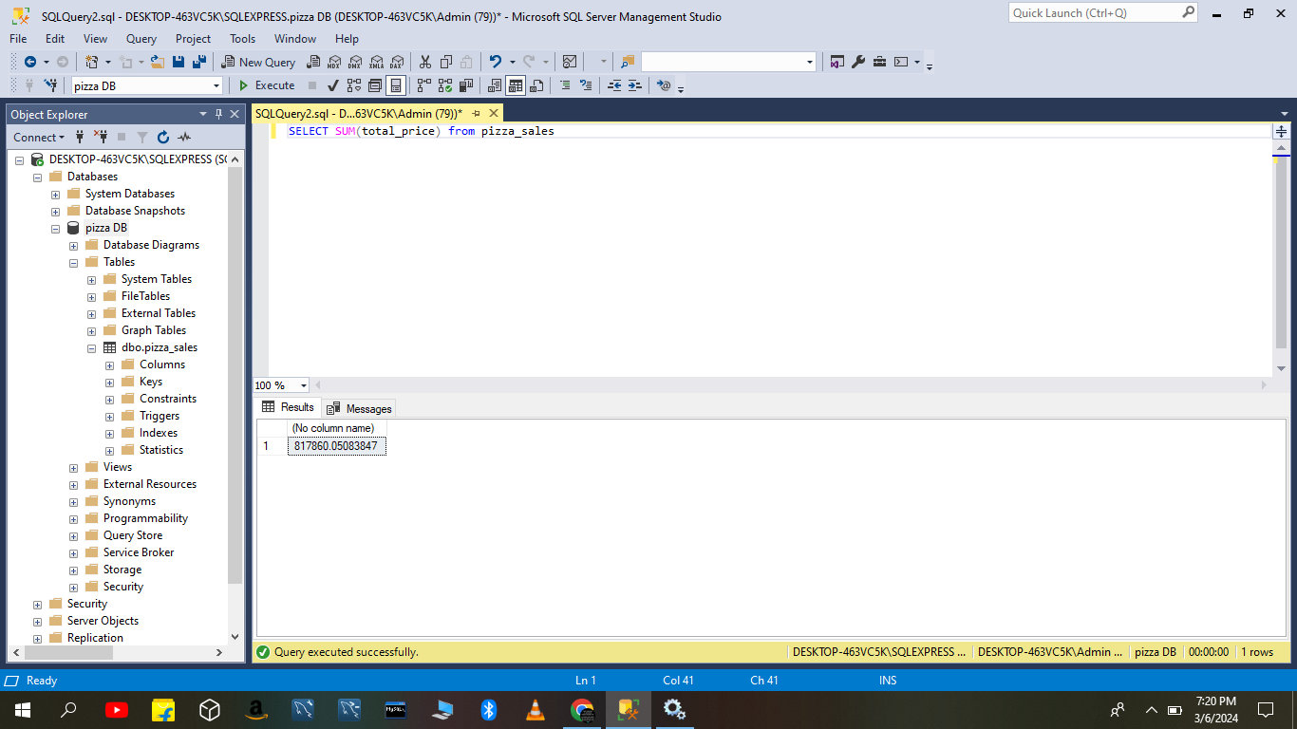

**#to give name use “AS TOTAL REVENUE”**

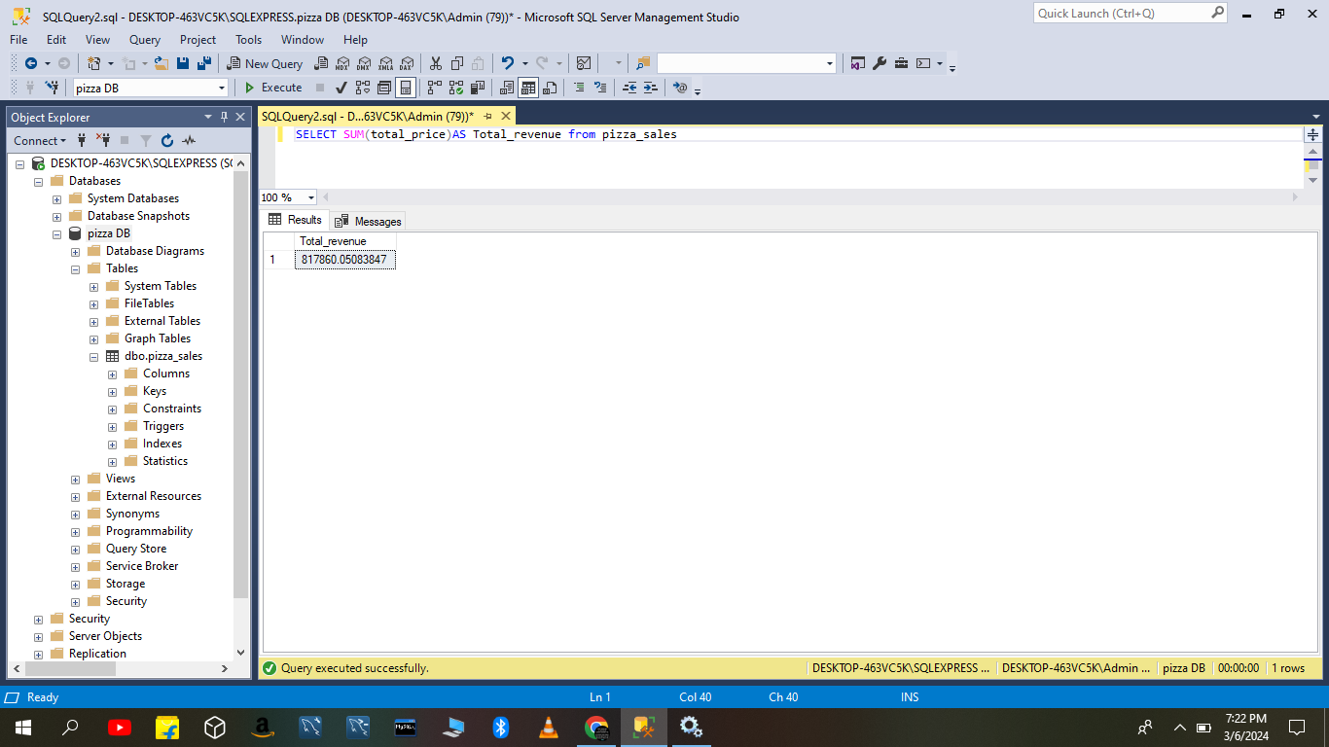

**B. TO FIND AVERAGE ORDER VALUE:**

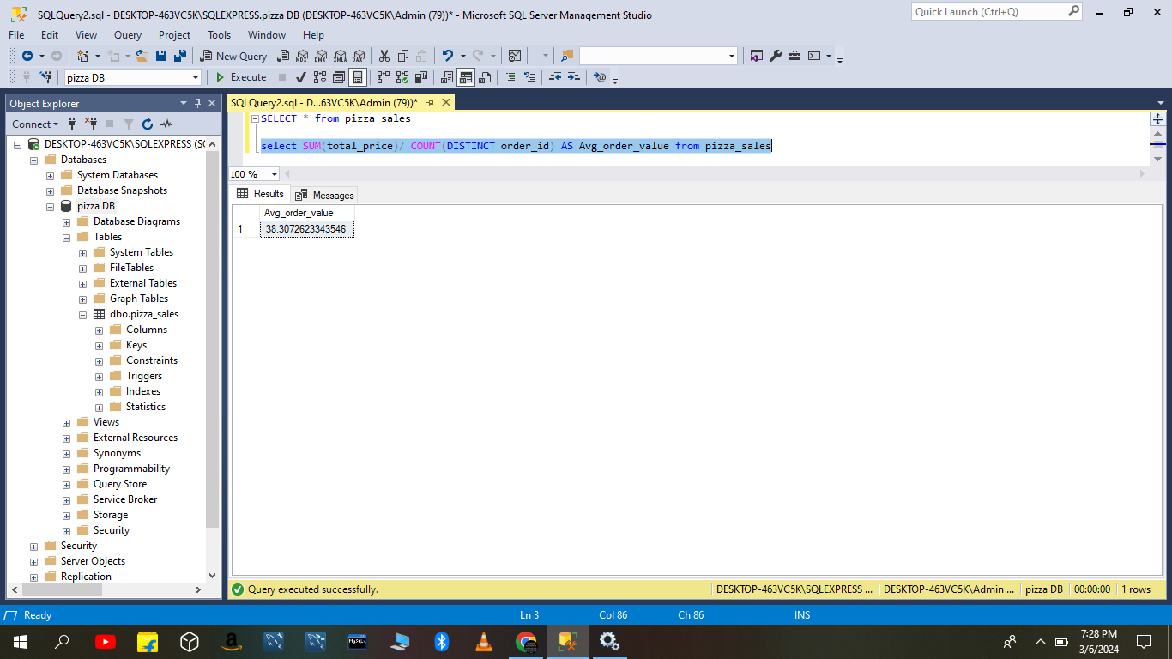

**C. TOTAL PIZZA SOLD**

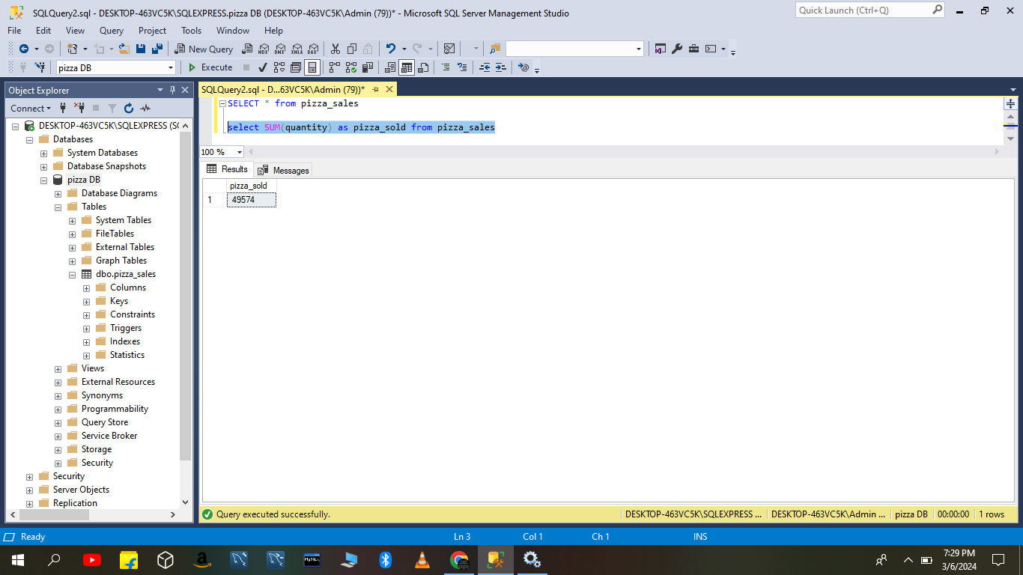

**D. TO FIND TOTAL ORDERS:**

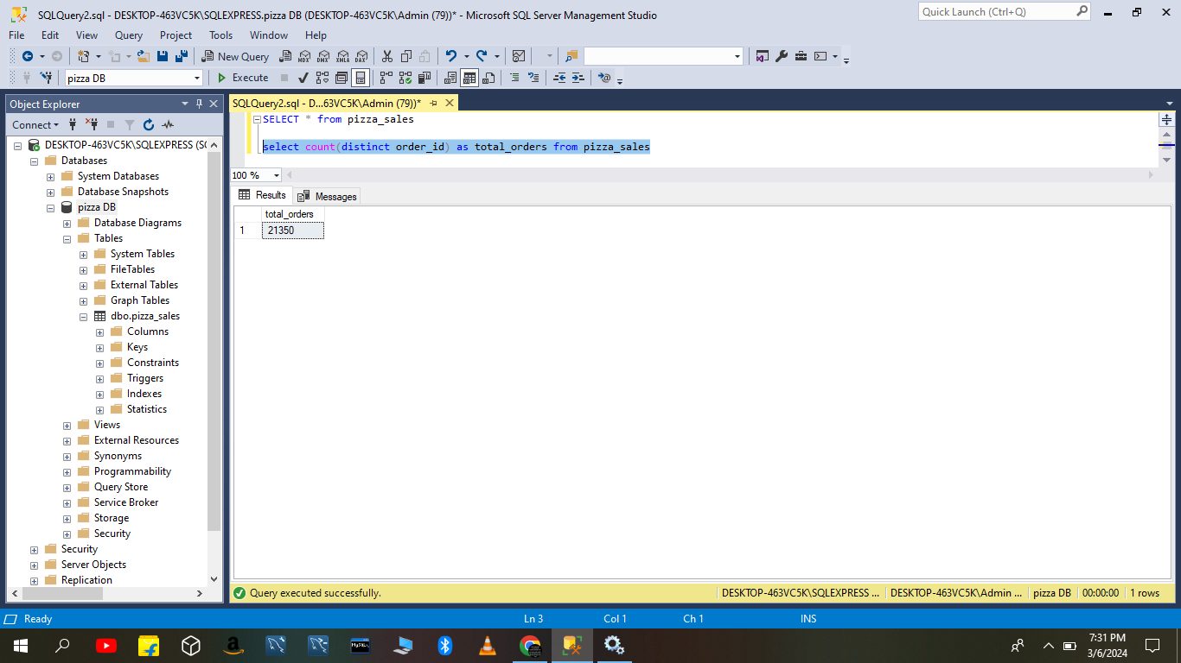

**E. TO FIND AVG PIZZA ORDER:**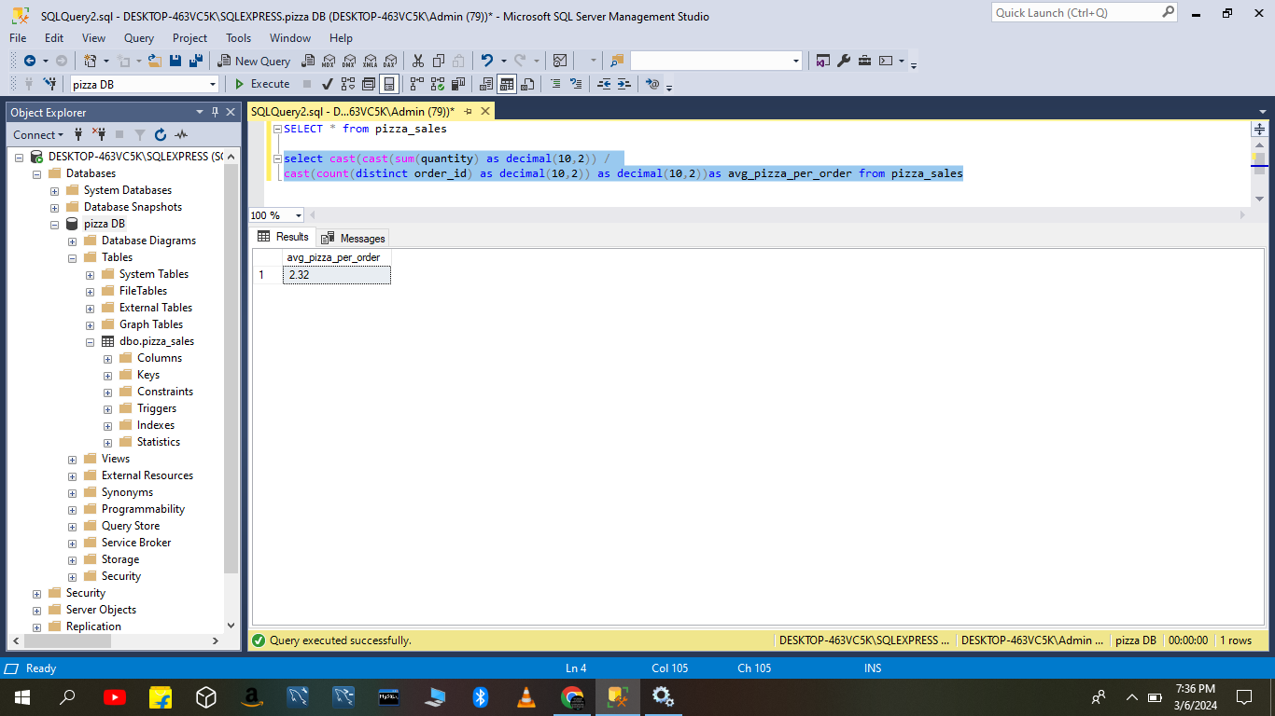

**F. SQL QUERY FOR DAILY TREND**

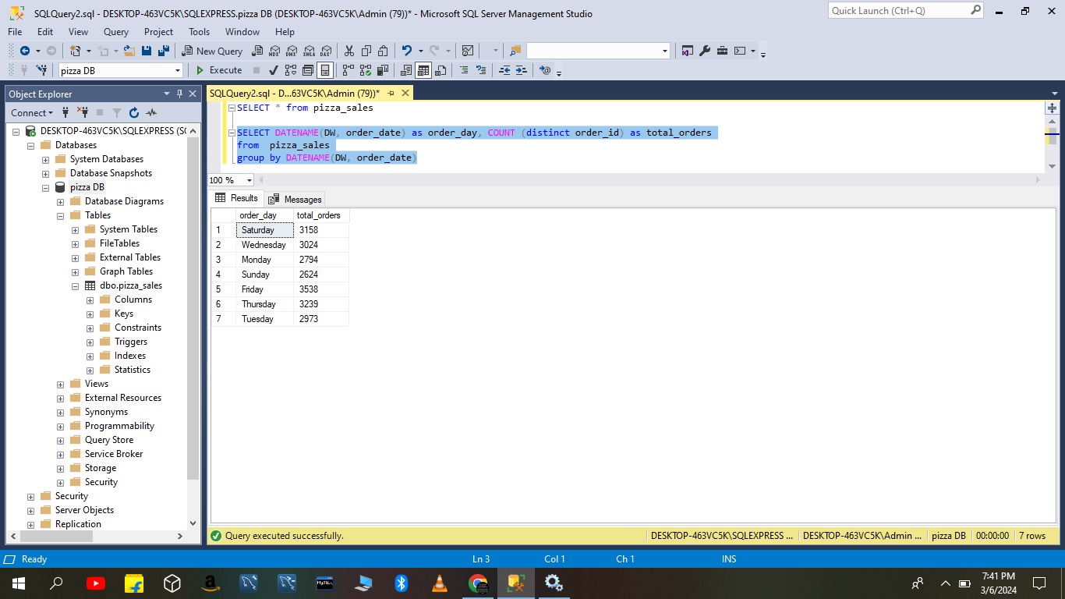

**G. SQL QUERY FOR MONTHLY TREND** 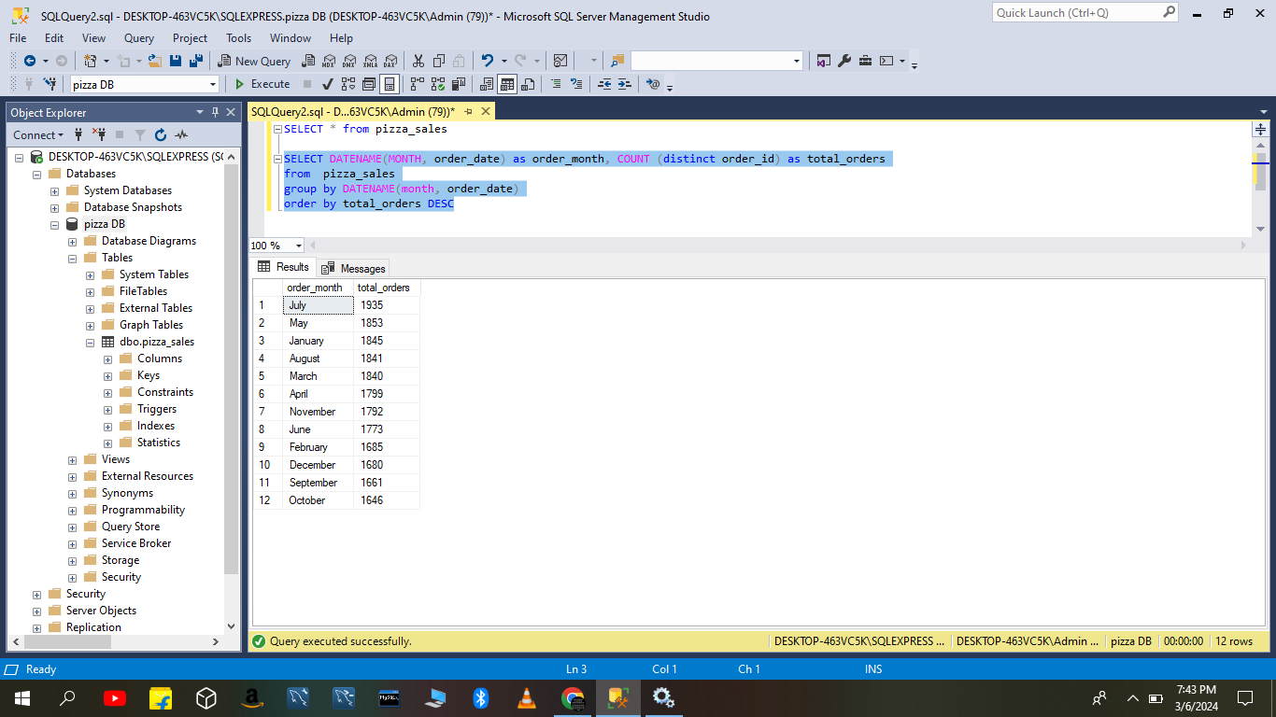

**H. % OF SALES BY CATEGORY**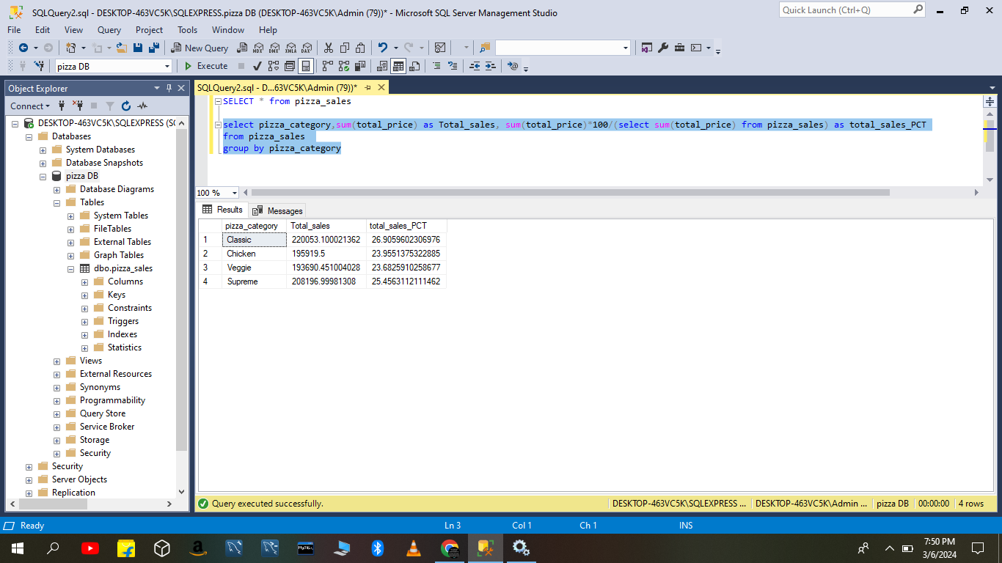

**I. % OF SALES BY CATEGORY FOR 1ST MONTH**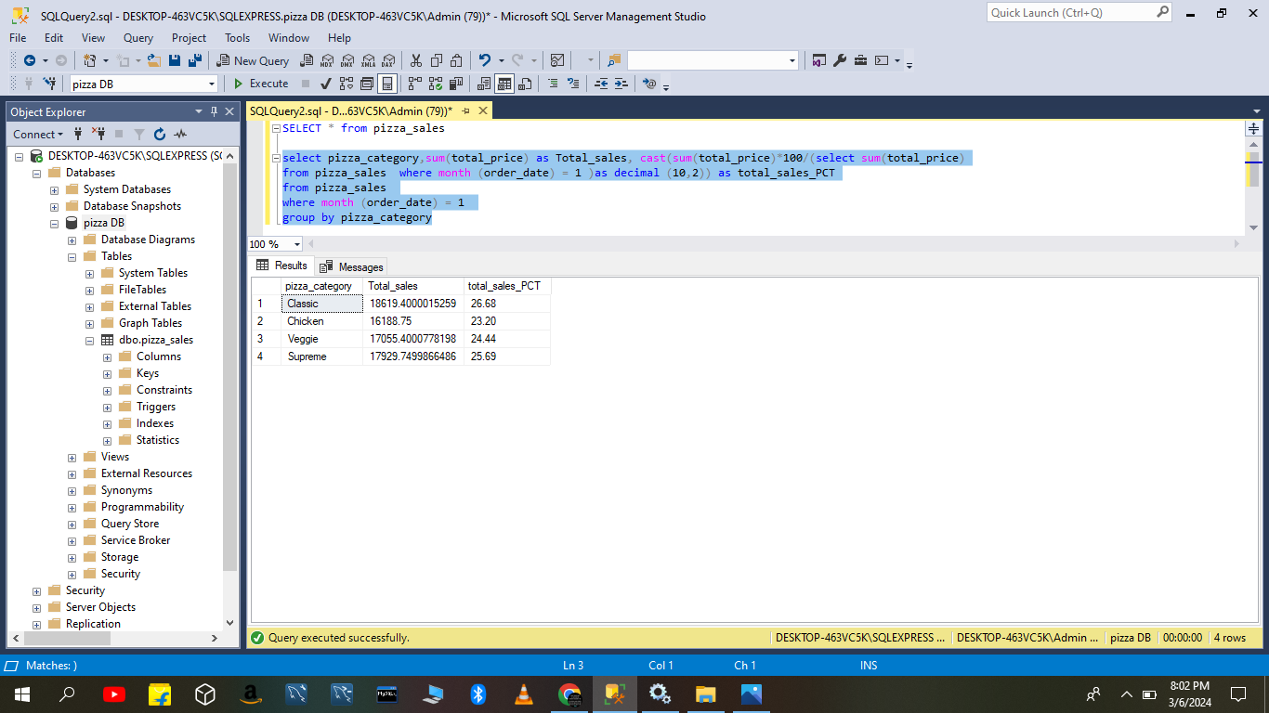

**J. % OF SALES BY SIZE FOR 1ST MONTH**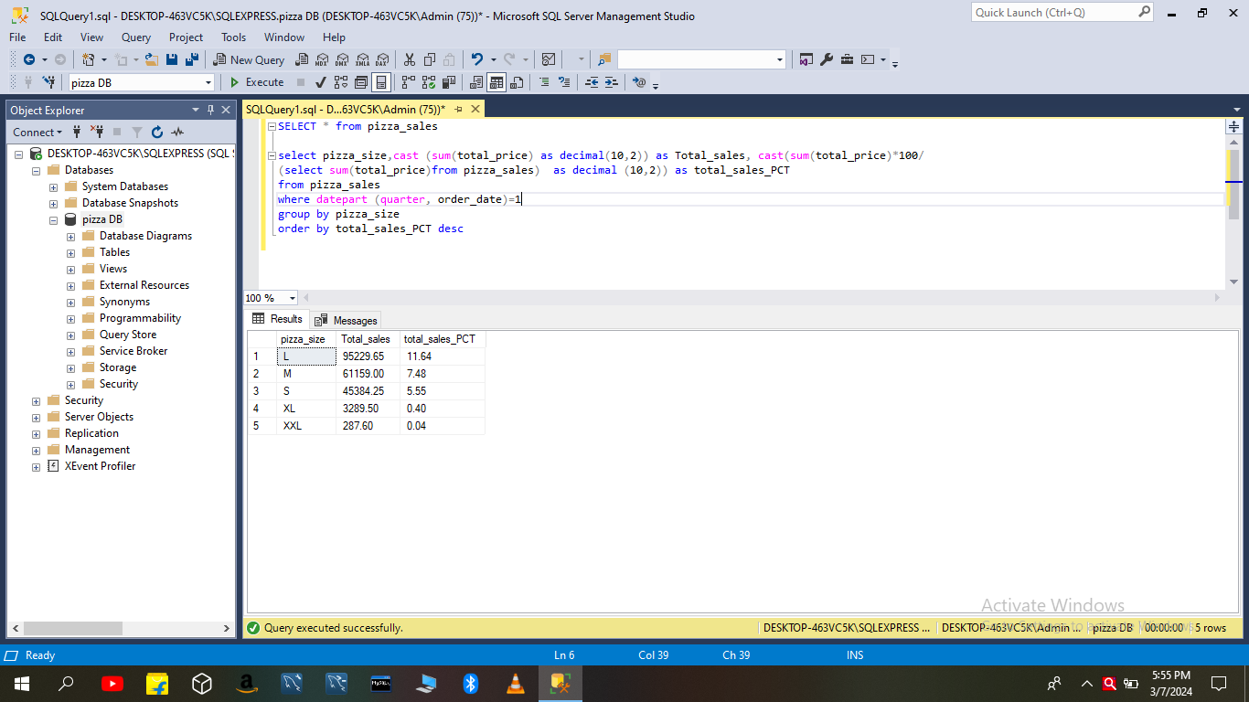

**K. TOP 5 SALES PIZZA BY REVENUE**

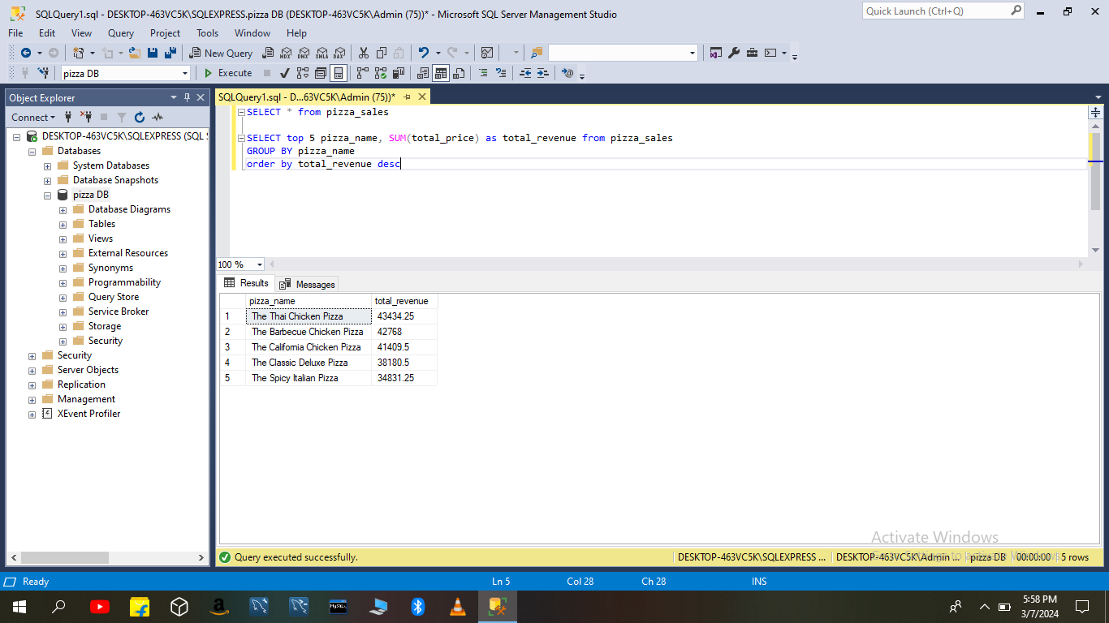

**L. BOTTOM 5 SALES PIZZA BY REVENUE**

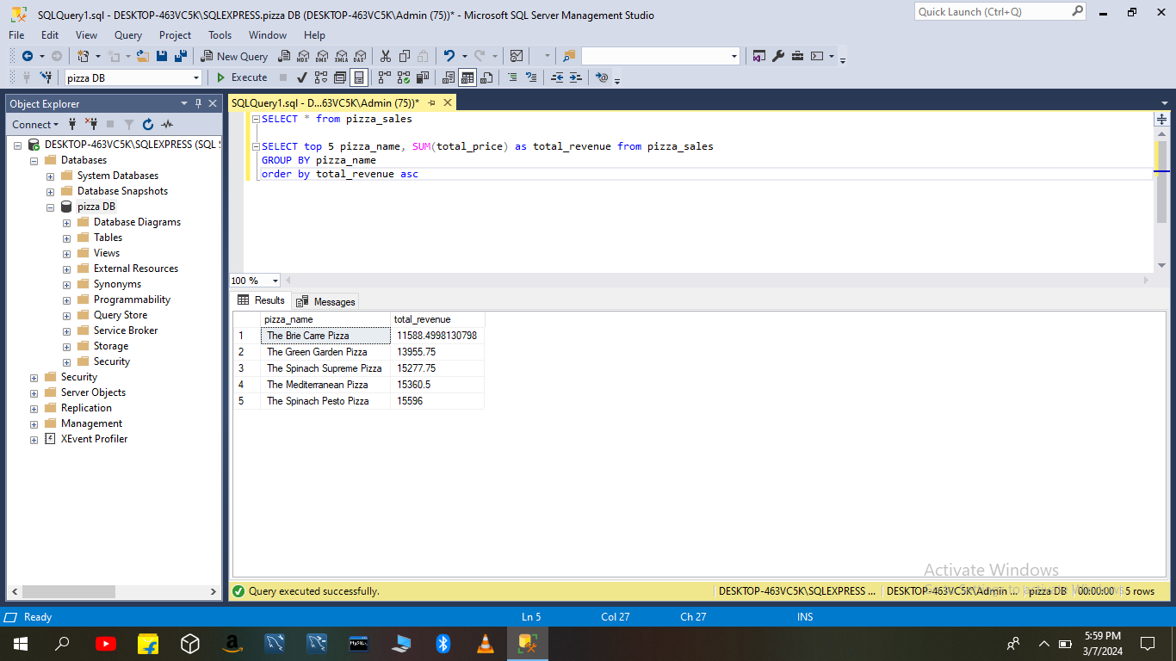

**M. BOTTOM 5 PIZZA SALES BY QUANTITY**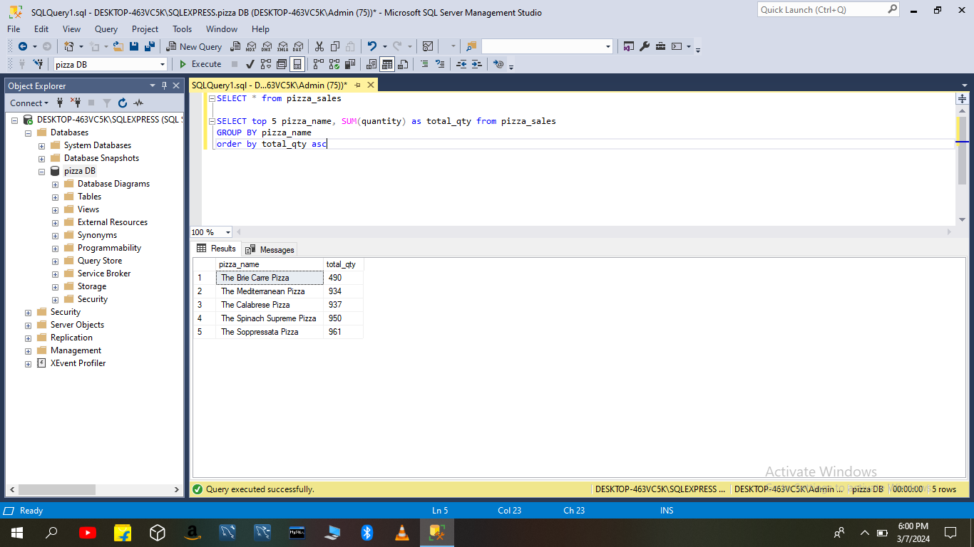

**N. TOP 5 PIZZA SALES BY QUANTITY**

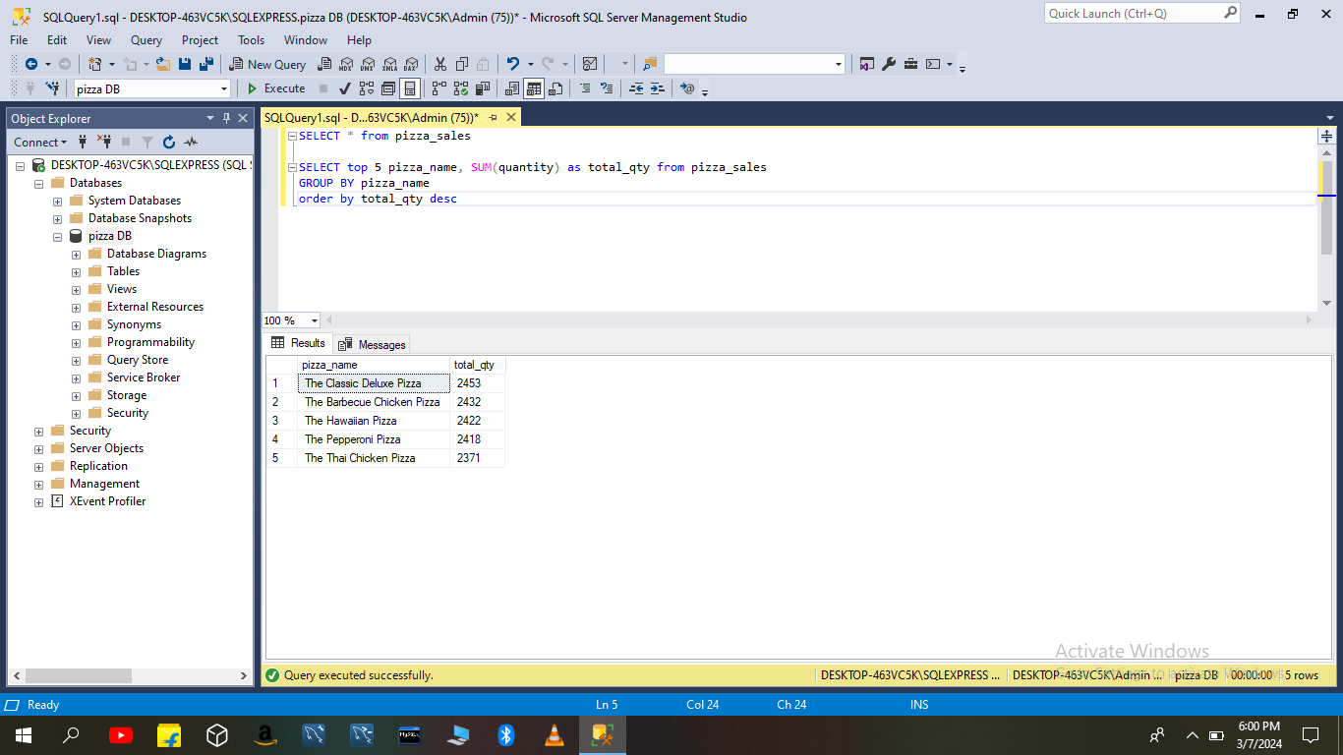

**O. BOTTOM 5 PIZZA SALES BY TOTAL ORDERS**

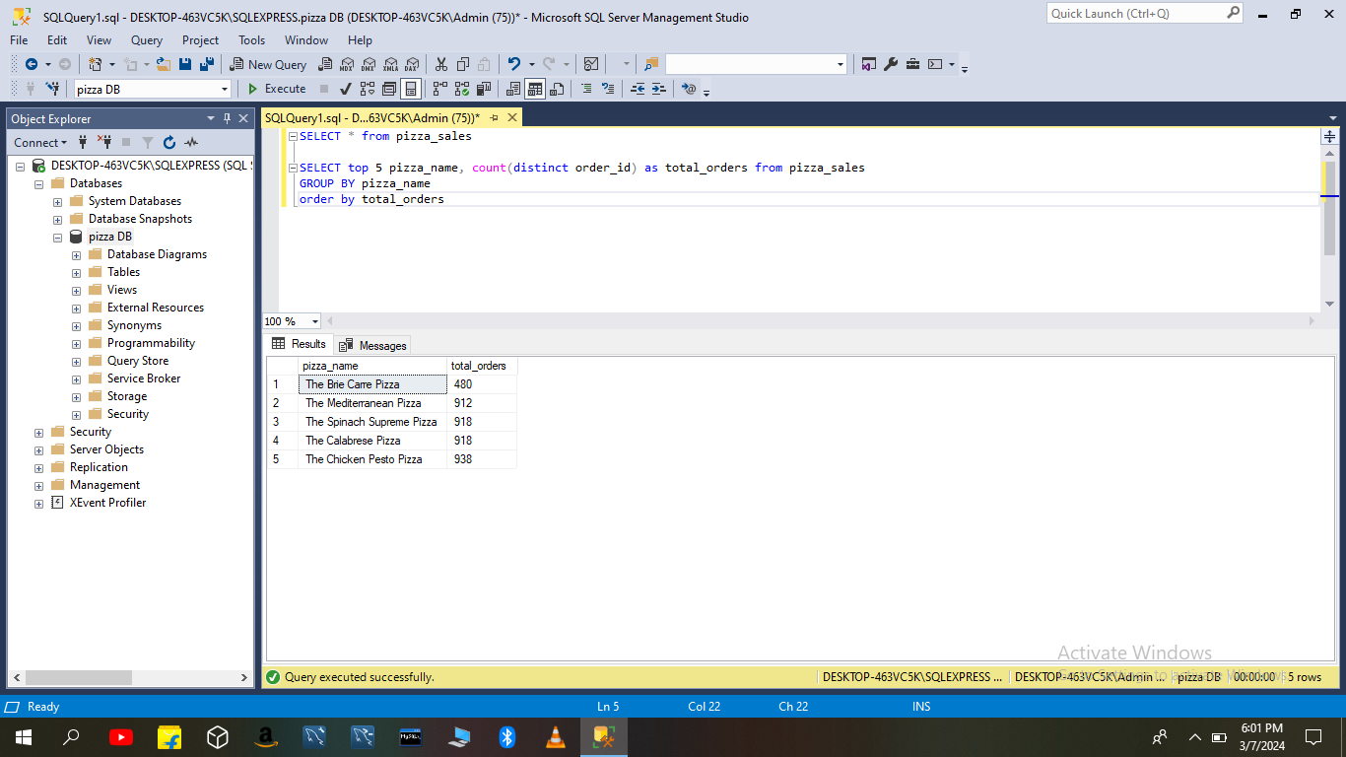

**P. TOP 5 PIZZA SALES BY TOTAL ORDERS**

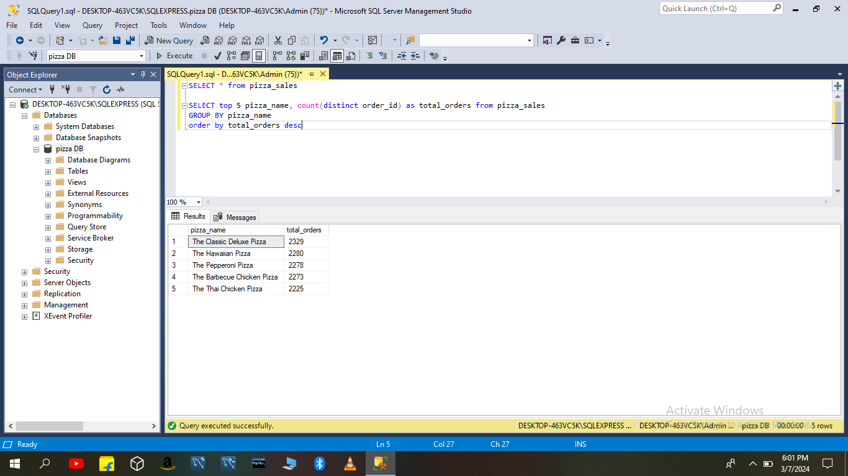

**VISUALIZATION IN POWER BI**

